Java If-else Statement
The Java if statement is used to test the condition. It checks boolean condition: true or false. There are various types of if statement in Java.
- if statement
- if-else statement
- if-else-if ladder
- nested if statement

Java if Statement
The Java if statement tests the condition. It executes the if block if condition is true.
Syntax:
if(condition){
//code to be executed
}
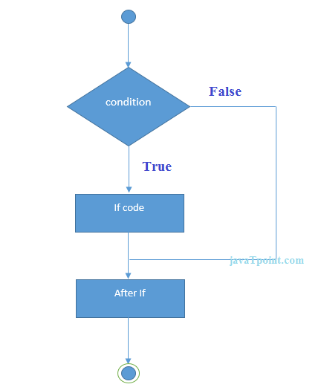
Example:
//Java Program to demonstate the use of if statement.
public class IfExample {
public static void main(String[] args) {
//defining an 'age' variable
int age=20;
//checking the age
if(age>18){
System.out.print("Age is greater than 18");
}
}
}
Test it Now
Output:
Age is greater than 18

Java if-else Statement
The Java if-else statement also tests the condition. It executes the if block if condition is true otherwise else block is executed.
Syntax:
if(condition){
//code if condition is true
}else{
//code if condition is false
}
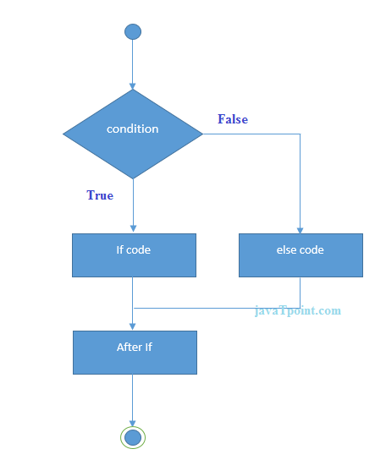
Example:
//A Java Program to demonstrate the use of if-else statement.
//It is a program of odd and even number.
public class IfElseExample {
public static void main(String[] args) {
//defining a variable
int number=13;
//Check if the number is divisible by 2 or not
if(number%2==0){
System.out.println("even number");
}else{
System.out.println("odd number");
}
}
}
Output:
odd number
Leap Year Example:
A year is leap, if it is divisible by 4 and 400. But, not by 100.
public class LeapYearExample {
public static void main(String[] args) {
int year=2020;
if(((year % 4 ==0) && (year % 100 !=0)) || (year % 400==0)){
System.out.println("LEAP YEAR");
}
else{
System.out.println("COMMON YEAR");
}
}
}
Output:
LEAP YEAR

Using Ternary Operator
We can also use ternary operator (? :) to perform the task of if...else statement. It is a shorthand way to check the condition. If the condition is true, the result of ? is returned. But, if the condition is false, the result of : is returned.
Example:
public class IfElseTernaryExample {
public static void main(String[] args) {
int number=13;
//Using ternary operator
String output=(number%2==0)?"even number":"odd number";
System.out.println(output);
}
}
Output:
odd number

Java if-else-if ladder Statement
The if-else-if ladder statement executes one condition from multiple statements.
Syntax:
if(condition1){
//code to be executed if condition1 is true
}else if(condition2){
//code to be executed if condition2 is true
}
else if(condition3){
//code to be executed if condition3 is true
}
...
else{
//code to be executed if all the conditions are false
}
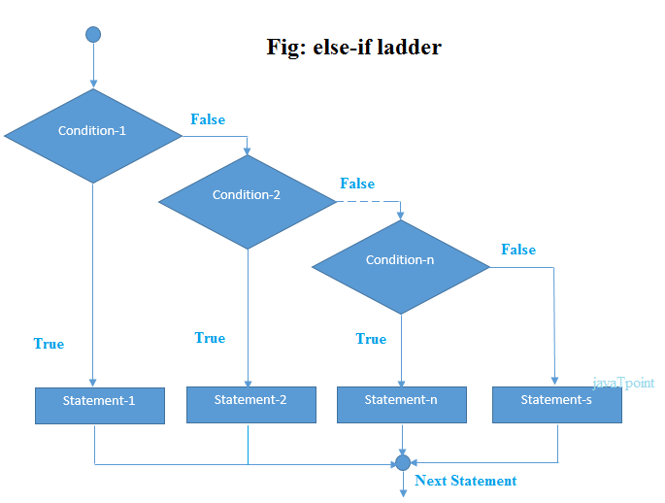
Example:
//Java Program to demonstrate the use of If else-if ladder.
//It is a program of grading system for fail, D grade, C grade, B grade, A grade and A+.
public class IfElseIfExample {
public static void main(Strin[] args) {
int marks=65;

if(marks<50){
System.out.println("fail");
}
else if(marks>=50 && marks<60){
System.out.println("D grade");
}
else if(marks>=60 && marks<70){
System.out.println("C grade");
}
else if(marks>=70 && marks<80){
System.out.println("B grade");
}
else if(marks>=80 && marks<90){
System.out.println("A grade");
}else if(marks>=90 && marks<100){
System.out.println("A+ grade");
}else{
System.out.println("Invalid!");
}
}
}
Output:
C grade
Program to check POSITIVE, NEGATIVE or ZERO:
public class PositiveNegativeExample {
public static void main(String[] args) {
int number=-13;
if(number>0){
System.out.println("POSITIVE");
}else if(number<0){
System.out.println("NEGATIVE");
}else{
System.out.println("ZERO");
}
}
}
Output:
NEGATIVE

Java Nested if statement
The nested if statement represents the if block within another if block. Here, the inner if block condition executes only when outer if block condition is true.
Syntax:
if(condition){
//code to be executed
if(condition){
//code to be executed
}
}
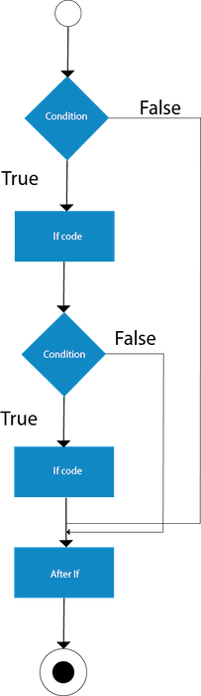
Example:
//Java Program to demonstrate the use of Nested If Statement.
public class JavaNestedIfExample {
public static void main(String[] args) {
//Creating two variables for age and weight
int age=20;
int weight=80;
//applying condition on age and weight
if(age>=18){
if(weight>50){
System.out.println("You are eligible to donate blood");
}
}
}}
Output:
You are eligible to donate blood
Example 2:
//Java Program to demonstrate the use of Nested If Statement.
public class JavaNestedIfExample2 {
public static void main(String[] args) {
//Creating two variables for age and weight
int age=25;
int weight=48;
//applying condition on age and weight
if(age>=18){
if(weight>50){
System.out.println("You are eligible to donate blood");
} else{
System.out.println("You are not eligible to donate blood");
}
} else{
System.out.println("Age must be greater than 18");
}
} }

Java Switch Statement
The Java switch statement executes one statement from multiple conditions. It is like if-else-if ladder statement. The switch statement works with byte, short, int, long, enum types, String and some wrapper types like Byte, Short, Int, and Long. Since Java 7, you can use strings in the switch statement.
In other words, the switch statement tests the equality of a variable against multiple values.

Points to Remember
- There can be one or N number of case values for a switch expression.
- The case value must be of switch expression type only. The case value must be literal or constant. It doesn't allow variables.
- The case values must be unique. In case of duplicate value, it renders compile-time error.
- The Java switch expression must be of byte, short, int, long (with its Wrapper type), enums and string.
- Each case statement can have a break statement which is optional. When control reaches to the break statement, it jumps the control after the switch expression. If a break statement is not found, it executes the next case.
- The case value can have a default label which is optional.
Syntax:
switch(expression){
case value1:
//code to be executed;
break; //optional
case value2:
//code to be executed;
break; //optional
......

default:
code to be executed if all cases are not matched;
}
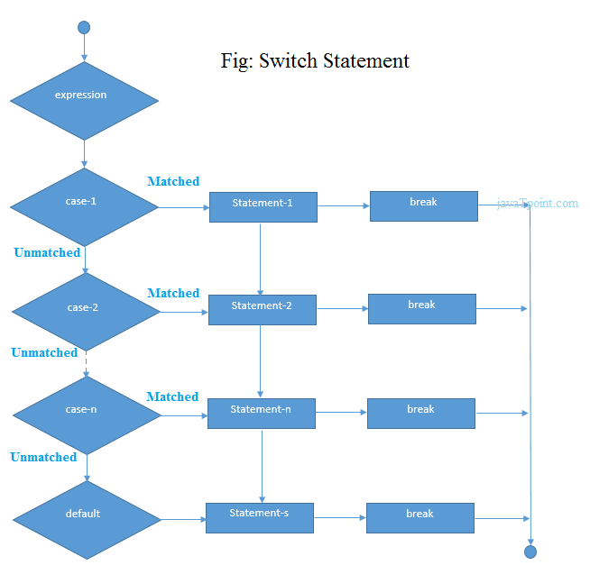
Example:
public class SwitchExample {
public static void main(String[] args) {
//Declaring a variable for switch expression
int number=20;
//Switch expression
switch(number){
//Case statements
case 10: System.out.println("10");
break;
case 20: System.out.println("20");
break;
case 30: System.out.println("30");
break;
//Default case statement
default:System.out.println("Not in 10, 20 or 30");
}
}
}
Output:
20
Finding Month Example:
//Java Program to demonstrate the example of Switch statement
//where we are printing month name for the given number
public class SwitchMonthExample {
public static void main(String[] args) {
//Specifying month number
int month=7;
String monthString="";
//Switch statement
switch(month){
//case statements within the switch block
case 1: monthString="1 - January";
break;
case 2: monthString="2 - February";
break;
case 3: monthString="3 - March";
break;
case 4: monthString="4 - April";
break;
case 5: monthString="5 - May";
break;
case 6: monthString="6 - June";
break;
case 7: monthString="7 - July";
break;
case 8: monthString="8 - August";
break;
case 9: monthString="9 - September";
break;
case 10: monthString="10 - October";
break;
case 11: monthString="11 - November";
break;
case 12: monthString="12 - December";
break;
default:System.out.println("Invalid Month!");
}
//Printing month of the given number
System.out.println(monthString);
}
}
Output:
7 - July
Program to check Vowel or Consonant:
If the character is A, E, I, O, or U, it is vowel otherwise consonant. It is not case-sensitive.
public class SwitchVowelExample {
public static void main(String[] args) {
char ch='O';
switch(ch)
{
case 'a':
System.out.println("Vowel");
break;
case 'e':
System.out.println("Vowel");
break;
case 'i':
System.out.println("Vowel");
break;
case 'o':
System.out.println("Vowel");
break;
case 'u':
System.out.println("Vowel");
break;
case 'A':
System.out.println("Vowel");
break;
case 'E':
System.out.println("Vowel");
break;
case 'I':
System.out.println("Vowel");
break;
case 'O':
System.out.println("Vowel");
break;
case 'U':
System.out.println("Vowel");
break;
default:
System.out.println("Consonant");
}
}
}
Output:
Vowel

